**Big Data Visualization Assignment – 3**

*Gaurang Ashava*

*RA2111027010007*

*Section – AA1*

*Department – DSBS*

Exercise 1: Import and Merge Data

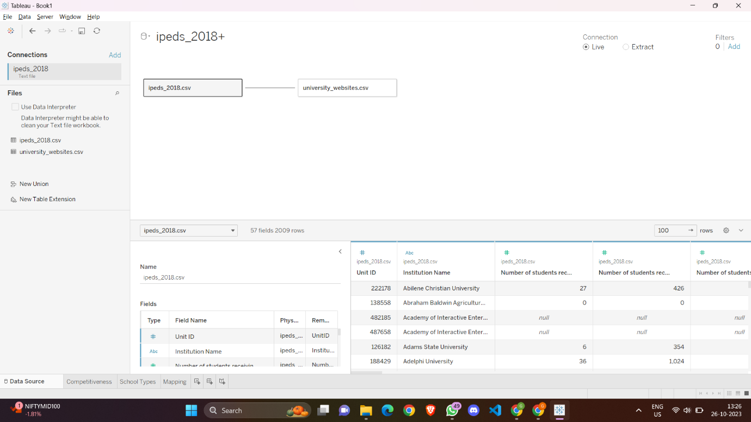

Exercise 2: Create Groups

Exercise 3: Create a Set

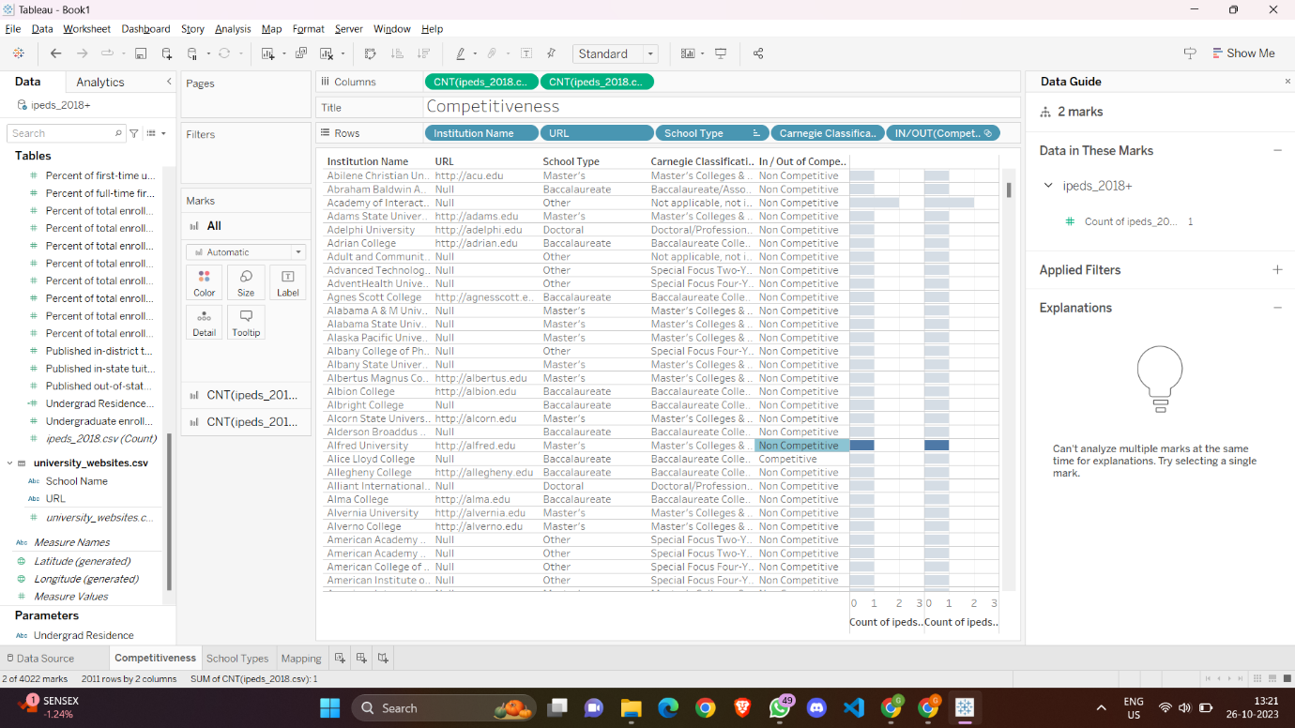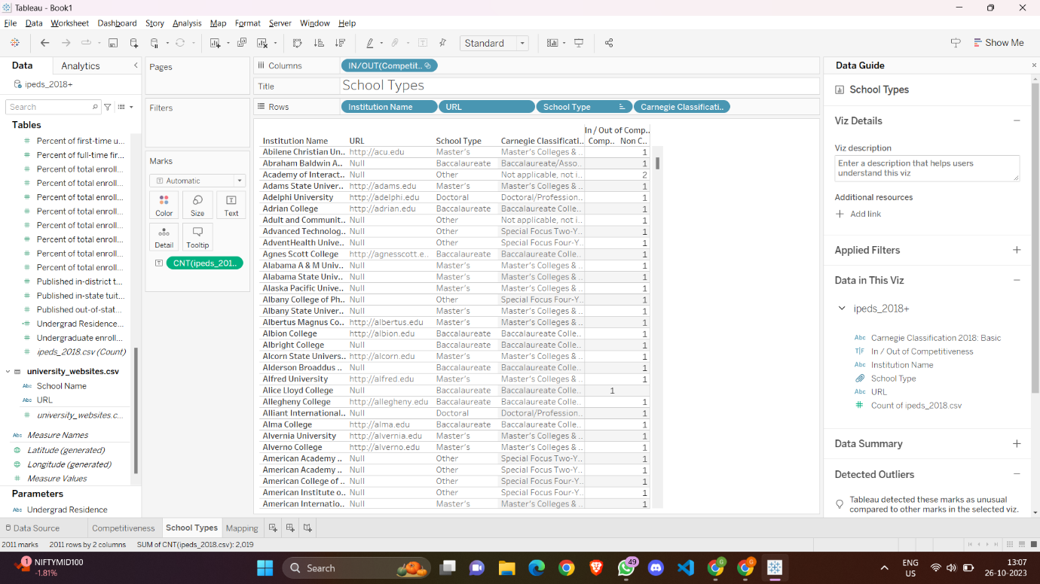

Exercise 4: Create an Interactive Menu to Explore Different Variables

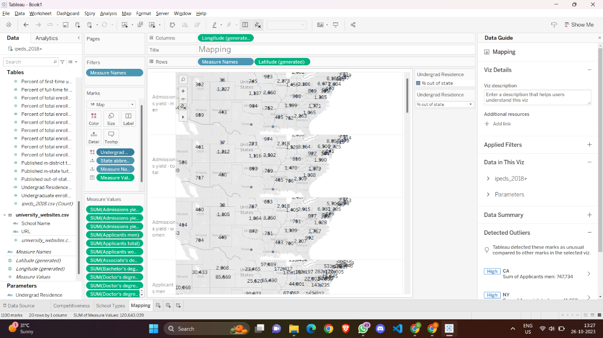

Exercise 5: Add Specific Locations and Customized Tooltips to the Map

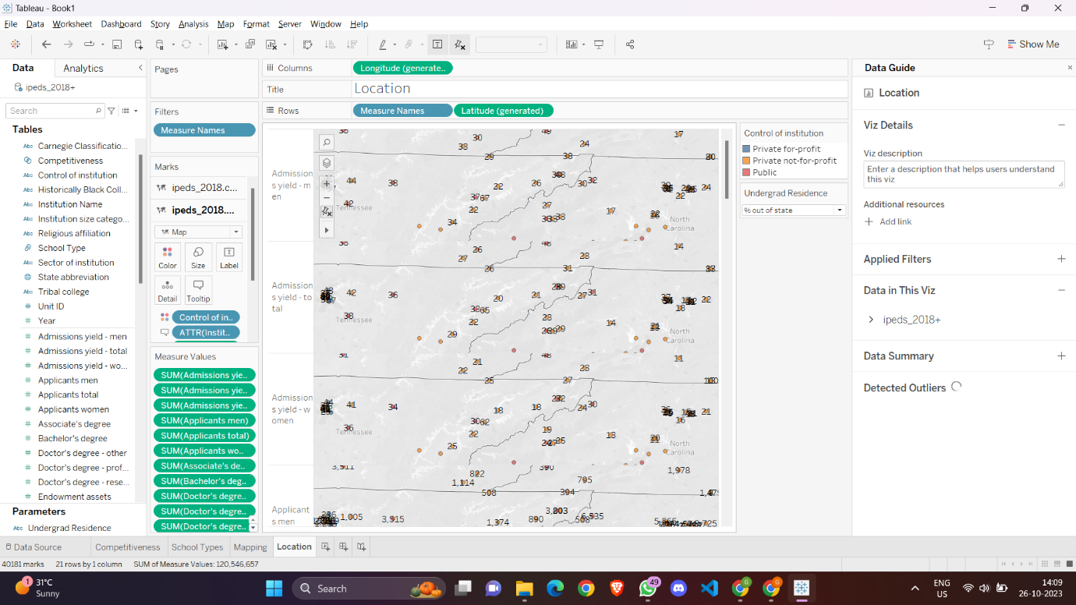

Exercise 6: Add a Worksheet Action to the map

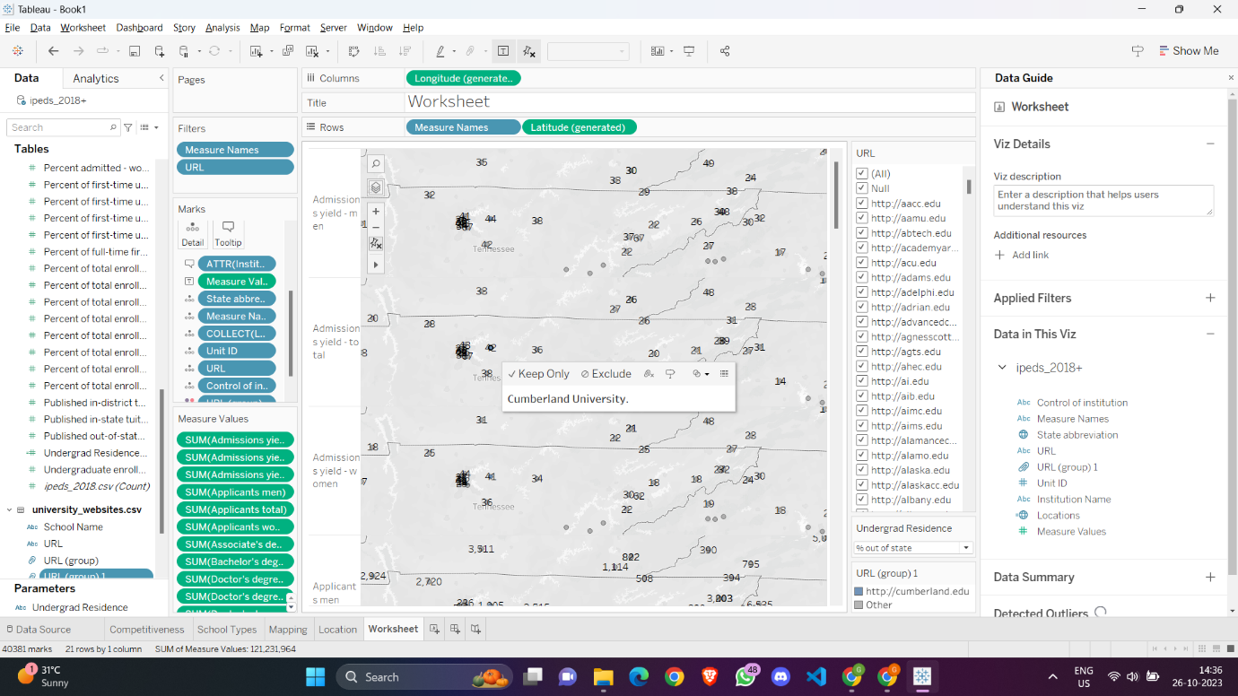

Exercise 7: Create a Dashboard and edit Dashboard Actions

